NorthJersey.com : Arts and Entertainment : Art

'Jersey Women Artists' exhibition in Montclair
March 29, 2014 Last updated: Saturday, March 29, 2014, 1:18 PM
By Gwen Orel
Staff Writer
The Montclair Times
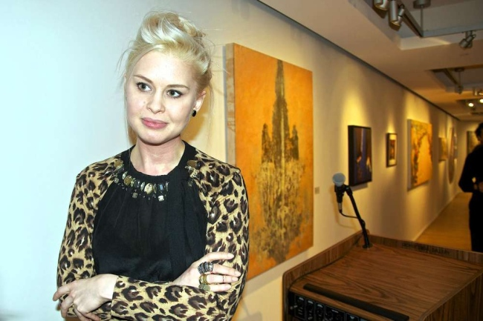
Why not a show of art by men?

M. Teresa Rodriguez, director of the George Segal Gallery, laughs at the question. "That's the whole point about this show," Rodriguez told The Montclair Times. "The gender inequality has been a problem for a long time."

"Jersey Women Artists Now: Contemporary Visions" opened at the George Segal Gallery on the campus of Montclair State University on March 6 and runs through Friday, April 19, exhibiting the work of 18 women artists from New Jersey. Rodriguez has wanted to hold this show for a long time.
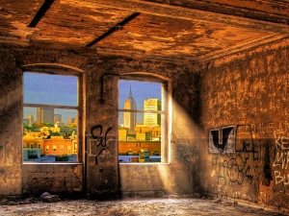
Above, curator Allison Leigh Staff photo by George Wirt.

"Jersey women issues have been in the minds of the state for 200 years. New Jersey is one of the states that supported the issues when they were very controversial. Women artists of New Jersey have been making their mark about their art for 200 years, and that's reason to celebrate.

"We haven't done a Jersey women artists show here ever."

At the opening reception last Thursday, March 20, curator Allison Leigh, a tall blonde woman in elegant heels, reveled in the company of artists and some of the students from the class she teaches at MSU titled "Women and Art."

"More women are graduating from M.F.A. programs than men," Leigh noted.

She will moderate a discussion on Wednesday, April 2, with artists Nancy Cohen, Nancy Ori, and Lizz Andronaco, at 3 p.m. in the gallery. On Thursday, April 10, Joan Marter will give a lecture on women artists there at 6 p.m.

In addition to choosing the art, Leigh wrote a penetrating "state of women's art" essay titled "Almost There" in the show catalog (see sidebar).

Lizz Andronaco, at 25, is one of the younger artists in the exhibition. Andronaco said she took Leigh's class. Her colorful work "Bearded Lady" explores gender and identity, she said. "We live by a binary, but there are plenty of people who feel like they are both," she said. "Everyone says feminism's over, but it's really not. Being a woman is being yourself, and that's definitely still harder for women."
Leigh teaches a course at MSU titled "Women and Art." The "and" is important, since it shows that it's about women who make art, not who are "in" the art work. Leigh said there is still a bias against women on the part of buyers and directors.

From 'Almost There: Jersey Women Artists Now' by Allison Leigh
In the catalog for "Jersey Women Artists Now: Contemporary Visions"

The current edition of one of the leading art history survey textbooks used in university classrooms nationwide, H.W. Janson's "History of Art," has only 27 women artists represented in its pages. And that number is up from the zero women artists (out of 3,000) included in the text in the 1980s. Janson himself famously justified his actions in 1979: "I have not been able to find a woman artist who clearly belongs in a one-volume history of art." ...This kind of blatant sexism among male academics led feminists of the 1970s and 1980s to describe the field of art history as instead, art "his-story."

Statistics and writings like these prove without a doubt that there is still a real need for shows devoted exclusively to works of art created by women. Shows like this one seek to redress the imbalance, but are nonetheless still part of the problem. ... By treating the art of women as separate from works created by men, we do not allow them to be appraised on equal footing. And this is not a new idea or problem within gender studies discourse. in the now seminal proto-feminist piece of 1792 titled "A Vindication of the Rights of Women," Nary Wollstonecraft Shelley devoted an entire chapter to this problem: "Of the Pernicious Effects Which Arise from the Unnatural Distinctions Established in Society." A recent interview with Dave Hickey also revealed similar strong anti-group show aspirations. While Hickey was not speaking specifically about gender, he nonetheless makes a relevant argument in saying, "I have a big problem with group shows. If I could abolish group shows from museums and group crits from graduate schools, I would be happy. They are both modalities of social control. You work your butt off to get out of a pigeonhole so some curator or professor can fit you into a new one." Likewise, Jerry Saltz has called the lack of works by women on view at MoMA "not only a failure of the imagination and a moral emergency; it amounts to apartheid." I agree, but not exactly with how he meant it. I see a further deeply troubling segregation in what lies at the other end of the spectrum - from not enough works by women on view to the exclusionary vision that is all-women group shows. ... Exhibitions dedicated to women artists alone are an apartheid of their own, one that perpetuates keeping women separate while trying to make them equal.

So how do I make peace with the fact that I am proudly curating a show devoted to women artists while at the same time believing that these kinds of shows perpetuate gender-based division and grow inequality while seeking to end it? First, I recognize that we live in an unfair and often contradictory world. But that I would rather see the works of women artists on view than invisible, or worse - completely absent. ... I believe it is better to be present than missing or lost, even if one is showing up or being presented not at their absolute best. And I believe one must choose one's battles. I would rather show the tremendous works by these 18 women artists in an imperfect ideological setting than leave them unseen in the artists' studios. Growing the world where the phrase "women artists" sounds as odd as "men artists" demands putting the works of women on view for all to see. And eventually the strength of the works alone, without any thought to the names of the artists or their reproductive organs, will be what gains them exhibition space. Or so I desperately want to believe.

Contact Gwen Orel at orel@northjersey.com
Tags:
Art | Montclair |

- See more at: http://www.northjersey.com/arts-and-entertainment/art/here-s-looking-at-their-work-jersey-women-artists-1.821315#sthash.YAlbG5Rq.dpuf

